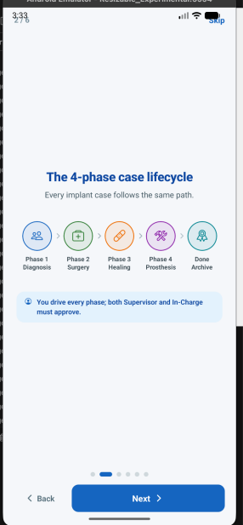
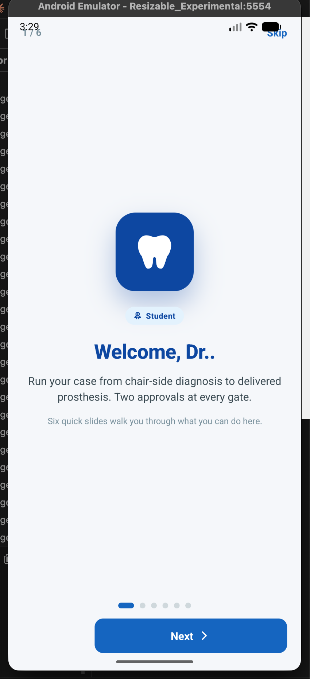
Dental Clinic Workflow
1) Show the name of user and change the role as per user
remove the text two approval at every gate

- Here show Only done instead of Done Archive and add 5th phase after done Maintenance Phase (for both clinic and college workflow )
Hide the blue box content
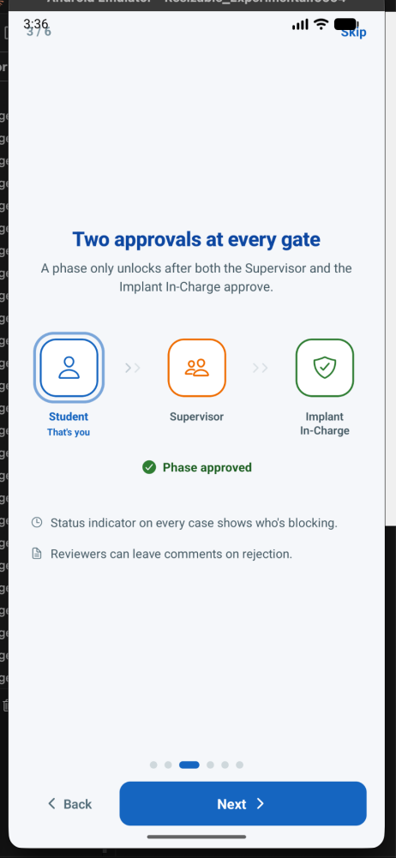
- Skip this slde

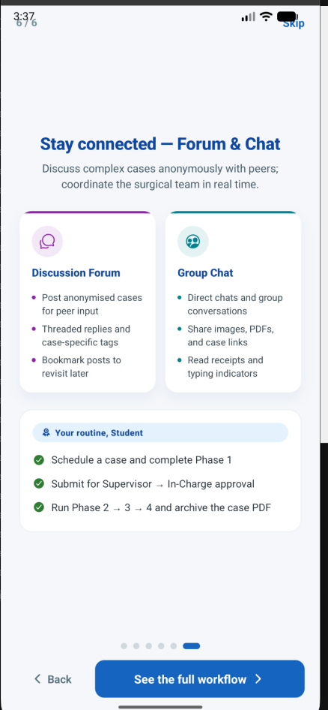
- Remove student from your routine and remove the 2nd point

- Add phase 5 after done (Maintenance Phase)
add these points
Track Implant survival and long term prognosis
And remove approval gate at a glance component from this slide
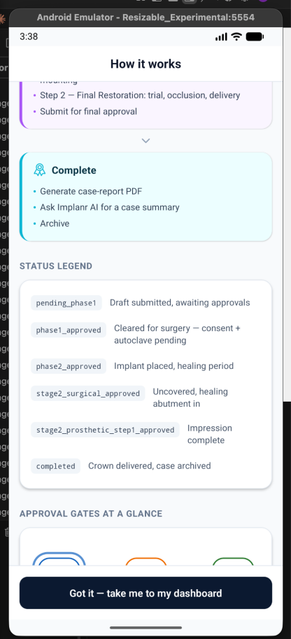

- Remove department from menu and add user tab

